

CLAimHealth:

COLLABORATING, LEARNING, AND ADAPTING FOR IMPROVED HEALTH ACTIVITY

*Good Practices and Promising Interventions, Technical Series No. 4*

The Critical Contributions of USAID to the Integrated Midwives of the Philippines' (IMAP) Journey Toward Self- Reliance

September 12, 2019

DISCLAIMER

The authors’ views expressed in this publication do not necessarily reflect the views of the United

States Agency for International Development or of the United States government.

This document was produced for review by the United States Agency for International Development (USAID). It was prepared by Panagora Group for the USAID/Philippines Collaborating, Learning, and Adapting for Improved Health (CLAimHealth) Activity, IDIQ No. AID-OAA-I-15-00025, Task Order No. 72049218F00001 as a Technical Deliverable per Task Order Section F.6 (b) and therefore uses USAID Branding as outlined in the CLAimHealth Branding and Marking Plan.

Recommended citation: USAID/Philippines Collaborating Learning and Adapting for Improved Health (CLAimHealth) Activity. 2019. The Critical Contributions of USAID to the Integrated Midwives Association of the Philippines’ Journey to Self-reliance, Technical Series No. 4. Silver Spring, Maryland: Panagora Group.

Panagora Group Contact:

Mary Ann Lansang, MD

Chief of Party

23/F Tower 1, The Enterprise Center

Makati City 1200, PhilippinesACKNOWLEDGMENTS

Panagora Group and CLAimHealth gratefully acknowledge the contributions of its technical consultants, Dr. Jesusa M. Marco and Dr. Maria Caridad H. Tarroja, in producing this report as well as the following resource persons, key informants, and stakeholders in the GPPI documentation:

|  |  |
| --- | --- |
| **USAID Office of Health**   * + Teresa Carpio   **IMAP National Officers**   * Patricia Gomez * Dr. Cesar Maglaya * Corazon Paras   **IMAP National Staff in San Juan, Metro Manila**   * Vanessa P. Gargabite * Mary Jane Domingo * Jessica Domalaoco * Janette Anne Morala   **IMAP Chapter Officers**   * Rowena Castro Yumang (Caloocan) * Gertrudes Luderico, RM, BSM (Pasig) * Cita Faderog (Taguig) * Rosalyn Olivar (Cavite) * Venus Balaga (Bohol)   **Provincial and Municipal Health Officers (Bohol)**   * Dr. Joni Lucero Co * Dr. Reymoses Cabagnot * Ma. Josiane Pepito | **IMAP Lying‐In Clinic Inc. Owners (Bohol)**   * Aludia Sepe   **IMAP Staff**   * Evelyn Diez (Bohol) * Janneth Anuba (Bohol) * Luz Lopos (Bohol) * Mae Elaine Arceli Apalisok (Bohol) * Hanna Maningo (Bohol) * Nonie Rica Amora (Bohol) * Merlina Loar (Caloocan) * Glendale Javier (Caloocan) * Elizabeth Centeno (Caloocan) * Charo Pascual (Quezon City) * Grazela Estanislao (Pasig) * Mary Cherilin Prado (Pasig)   **IMAP Lying‐In Clinic Inc. Service Recipients (Bohol)**   * Angely Tamayo * Rosalita Degamo * Reygan Degamo |

CONTENTS

Executive Summary vii

1. Overview 1

2. Background 2

3. Methods 3

4. Findings 4

4.3.1 Accreditations, Awards, and Memberships in National and International Organizations 6

4.3.2 Bachelor of Science in Midwifery 6

4.3.3 USAID TA to Individual Midwives 6

4.4.1 Community Maternal, Neonatal, Child Health, and Nutrition Scale-up 10

4.4.2 Improvement of Midwives’ Clinical Skills 10

4.4.3 Expanding the Reach of Midwives 12

4.4.4 Strengthening IMAP’s Capacity 12

4.4.5 Community Maternal, Neonatal, Child Health, and Nutrition Scale-up Follow-on 13

4.4.6 Other Development Partners Supporting IMAP 13

5. Analysis: Taking Wing—Is IMAP well on its way toward achieving self-reliance? 14

5.1.1 Legal Personality 15

5.1.2 Governance and Organization 15

5.1.3 Membership 16

5.1.4 Assets, Revenues, and Financial Capacity 16

5.1.5 Accreditations, Awards and Certifications 17

5.1.6 IMAP’s Visibility in the National and International Scenes 17

5.1.7 Internal Control Systems 18

5.2.1 As FP/MNCH Provider 18

5.2.2 As Training Provider 19

5.2.3 As a Social Enterprise Operator/Manager 20

5.3.1 Responsive Governance 21

6. Development Challenges 24

7. Conclusion 26

8. The Way Forward 29

References 31

ABBREVIATIONS AND ACRONYMS

|  |  |
| --- | --- |
| 3Ms | Mentoring and Monitoring Midwives Program |
| 4Ps | *Pantawid Pamilyang Pilipino* Program |
| ALSHRE | Adolescent Life Skills and Reproductive Health Education |
| ANC | Antenatal care |
| CHED | Commission on Higher Education |
| CHO | City Health Office |
| CHT | Community Health Team |
| CLAimHealth | Collaborating, Learning, and Adapting for Improved Health |
| CMSU | Community Maternal, Neonatal, Child Health and Nutrition Scale-up |
| CMSU2 | Community Maternal Neonatal Child Health and Nutrition Scale Up Follow-on |
| CPD | Continuing professional development |
| DOH | Department of Health |
| EINC | Essential intrapartum and newborn care |
| FGD | Focus group discussion |
| FP | Family planning |
| GIDA | Geographically Isolated and Disadvantaged Areas |
| GPPI | Good practices and promising interventions |
| ICM | International Confederation of Midwives |
| IMAP | Integrated Midwives Association of the Philippines |
| IMCCSDI | Integrated Maternal and Child Care Services and Development, Inc. |
| IMCH | Institute of Maternal and Child Health |
| IP | Implementing partner |
| IUD | Intrauterine device |
| KII | Key informant interview |
| LGU | Local government unit |
| LIC | Lying-In Clinic |
| MAPEH | Music, Arts, Physical Education and Health |
| MCP | Midwife Certification Program |
| MDGs | Millennium Development Goals |
| MNCHN | Maternal, newborn, and child health and nutrition |
| MSD | Merck Sharp & Dohme |
| NFFM | The National Federation of Filipino Midwives |
| NGO | Nongovernmental organization |
| NHS | National High School |
| NUPAS | Non-U.S. Organization Pre-Award Survey |
| PhilHealth | Philippine Health Insurance Corporation |
| PHIMIDAS | Philippine Midwives Association |
| PHO/MHO | Provincial/Municipal Health Office |
| POPCOM | The Commission on Population |
| PPM | Private practice midwives |
| PRC | Professional Regulation Commission |
| PRISM | Private Sector Mobilization for Family Health Project |
| PRISM2 | Philippines Private Sector Mobilization for Family Health Projects |
| PSI | Progestin subdermal implant |
| RHU | Rural Health Unit |
| SDN | Service delivery network |
| SEC | Securities and Exchange Commission |
| STTA | Short-term technical assistance |
| TA | Technical assistance |
| UNICEF | United Nations International Children’s Emergency Fund |
| USAID | U.S. Agency for International Development |
| VHPP | Visiting Health Professionals Program |
| WFMC | Well-Family Midwife Clinics |
| WPFI | WFMC Partnership Foundation, Inc. |

# Executive Summary

*“Awakening is not a thing. It is not a goal, not a concept. It is not something to be attained. It is a metamorphosis. If the caterpillar thinks about the butterfly it is to become, saying ‘And then I shall have wings and antennae’, there will never be a butterfly. The caterpillar must accept its own disappearance in its transformation. When the marvelous butterfly takes wing, nothing of the caterpillar remains.”*

*- Alejandra Jodorowsky*

This documentation study traces the metamorphosis of the Integrated Midwives Association of the Philippines (IMAP), a nonprofit private professional organization, from the breaking of the shell (1975 to 1992), to the time the caterpillar took form (1993 to 2011), to the time that the chrysalis unraveled (2012 to present) so that it could eventually take wing (become self-reliant). It gained relevance in every stage as it responded to the evolving demands of women, couples, families, and communities.

Though IMAP appears to be on a solid trajectory toward self-reliance, there has been no systematic effort to validate this. Therefore, in collaboration with IMAP, the Collaborating, Learning and Adapting for Improved Health (CLAimHealth) activity managed the task of documenting IMAP’s self-reliance journey, assessing its progress toward this goal based primarily on two key factors: the extent of its capacity to function independently, and its commitment to promoting the midwifery profession and supporting its members to provide the highest quality care possible.

Guided by eight learning questions, CLAimHealth’s documentation team collected data through observation, desk review of documents and reports, key informant interviews (KIIs), and focus group discussions (FGDs). The team conducted fieldwork from December 10, 2018 to January 17, 2019.

**FINDINGSFINDINGS**

Since its founding in 1975, IMAP has been led by committed and accomplished presidents with a diversity of expertise. Over the years, they have collectively established a viable organizational structure that is inclusive of its broad membership and spans the archipelago; and a system of procedures, guidelines, and policies to govern the general operations of the association and guide its members.

The caterpillar took form when USAID provided technical assistance (TA) to individual midwives who were IMAP members. USAID’s Technical Assistance for the Conduct of Integrated Family Planning/Maternal Health Activities by Philippine NGOs (TANGO) and TANGO 2,though not yet directly supporting IMAP,helped build and strengthen the profession in working to strengthen the capacity of midwives and their enterprises. TANGO worked closely with the Institute of Maternal and Child Health (IMCH) and the Integrated Maternal and Child Care Services and Development, Inc. (IMCCSDI). TANGO converted clinics into franchises and trained the new owners on family planning (FP) service delivery and counseling. TANGO 2 worked closely with nongovernmental organizations (NGOs) and midwives with no prior affiliation with IMCH and IMCCSDI who would later make up the Well-Family Midwife Clinics (WFMCs) project. WFMC developed, implemented, and evaluated the private sector-oriented models of service delivery for FP and basic MCH services.

USAID’s Private Sector Mobilization for Family Health project (PRISM) and PRISM2collaborated with health NGOs, microfinancing institutions, and midwives’ associations (including IMAP) and provided TA to individual private practice midwives (PPMs) with birthing homes. PRISM helped increase the number of midwives with successful practices, working with IMAP’s Bohol chapter to help PPMs get accredited by PhilHealth (the social insurance arm of the Department of Health). PRISM2 capacitated the PPMs to partner with city, provincial, and municipal health offices in the delivery of quality and affordable FP and maternal, newborn, and child health and nutrition (MNCHN) services. It continued to help PPMs obtain PhilHealth accreditation as service providers and as operators/owners of private birthing homes. It also facilitated the integration of PPMs and private birthing homes to the local service delivery network (SDN). Through PRISM2, IMAP was able to provide training on FP Competency-Based Training (FPCBT) Levels 1 and 2 (in Bohol and Cebu) during the Usapan[1] sessions.[2]

The chrysalis unraveled between 2008-2016, as USAID focused on capacitating IMAP as an association. A USAID senior financial officer assisted IMAP to pass the Non-U.S. Organization Pre-Award Survey (NUPAS), which assesses an organization’s management capacity to receive support from USAID. As a result, USAID granted conditional approval for IMAP to implement the Community Maternal, Neonatal, Child Health, and Nutrition Scale-up project (CMSU) and USAID’s senior financial analyst helped IMAP develop a corrective action plan to be executed in the first six months of CMSU implementation. In addition, IMAP benefited from TA from another USAID-supported activity called Strengthening CSOs. **CMSU** (2012- 2016) addressed the Millennium Development Goals (MDGs) on reducing child mortality and improving maternal health. CMSU worked in provinces and cities with a high need for MNCHN and FP services **CMSU2** (2016 – 2019) further developed IMAP’s clinical, mentoring, and organizational capacity, which enabled the association to develop leaders, trainers, and mentors. It improved the quality of midwifery care through hands-on peer mentoring and monitoring. It also strengthened the role of private midwives, expanding their reach through the establishment of public-private partnerships (PPP) to include FP service provision to their practices.[3]

**DEVELOPMENT CHALLENGES AND HOW THEY HAVE BEEN ADDRESSED**

Though IMAP’s steady journey toward self-reliance was not spared of challenges and difficulties, the association has been able to address these with the strong leadership support of its key officers.

**Compliance with Requirements.** Complying with the requirements to pass the NUPAS tool to receive USAID support was a challenge, though ultimately IMAP’s leaders pursued this and succeeded. Private midwives also faced challenges in processing applications and complying with requirements to set up their birthing clinics. This was resolved with the help of the IMAP president and the IMAP CEO, who negotiated with the Department of Health (DOH) to reduce the space required to establish a birthing clinic.

**Need for a Training Facility**. Developing the capacity of midwives as service providers forFP/MNCHN and as trainers of their colleagues was a challenge because IMAP had only one training site, in Manila, creating an administrative and financial burden of arranging for trainees’ travel and accommodation. Given the positive response of midwives in Bohol, IMAP put up another training center in Totolan, Dauis, Bohol, which caters to midwives in the Visayas region. In Metro Manila, IMAP’s training center in Pasig has been operational since January 2019.

**Emergence of Other Birthing Facilities.** IMAP has needed to contend with competition with theemergence of public birthing facilities and associated tensions about whether potential clients might be incentivized to choose one type of facility over another. However, according to one municipal health officer, pregnant women can always choose from several options for their preferred birthing facility, and there is no coercion or competition between municipal birthing facilities and the IMAP’s lying-in clinics (LICs). Ultimately, it is the mother who chooses the facility where she prefers to give birth.

**Dual Midwives.** Some IMAP midwives who practice in public birthing clinics also work in private practice. This has led to allegations of conflict of interest, with the perception that these midwives “lure” pregnant women to deliver in IMAP LICs or keep clients away from public birthing facilities. Though they contend that these allegations are baseless, the IMAP midwives decided to give up their public practice.

**Financial Issues of LICs.** IMAP found that intensified FP advocacy has led to fewer childbirths in its birthing facilities. Another source of financial strain stems from the two- to three-month delay in the PhilHealth reimbursements, which disrupts the daily operations, financial management, and budgeting of the IMAP LICs. To compensate for the reduced and delayed revenue, some clinics began offering peripheral services such as ear piercing and circumcision. Some clients also pay a small fee for antenatal and well-baby checkups. Others resort to taking out high-interest loans.

**The Need to Professionalize Midwifery.** Raising the standards of the profession has been adevelopmental challenge that IMAP continues to confront. IMAP has succeeded in pushing for a two-year midwifery program that serves as a prerequisite for the four-year Bachelor of Science in Midwifery. IMAP aims to draft a roadmap for the continued progression of the professionalization of midwifery.

**Reaching the High-Risk and Geographically Isolated and Disadvantaged Area (GIDA)** **Communities**. IMAP is collaborating with local government units (LGUs) in high-risk areas and GIDAs for the provision of FP/MNCHN services. Given the risk involved in working in these remote areas and considering the safety of midwives, IMAP is looking at all possibilities and treating the situation with utmost care.

**CONCLUSION**

In the process of documenting the IMAP journey to self-reliance, CLAimHealth’s documentation focused on the evolution of IMAP’s capacity and commitment. USAID’s TA over the years has facilitated IMAP’s and its members’ work to provide quality FP/MNCHN services and to make inroads in addressing the MDGs. IMAP has proven itself capable and competent in delivering MNCHN and modern FP services to its clients and conducting training and continuing professional development (CPD) seminars and workshops for its members. It helped to establish and accredit private midwives’ clinics (LICs/birthing facilities) in the Visayas, especially in the provinces of Bohol and Cebu. The Bohol IMAP LICs collaborate efficiently and effectively with local government and have proven PPPs to be a viable route for the delivery of FP/MNCHN information, services, and counseling.

IMAP has matured into an organization for midwives who have undergone rigorous training, mentoring, and monitoring on provision of FP/MNCHN services and on running a social enterprise with DOH and PhilHealth accreditation. IMAP members are tapped by the PHO, MHO, and Rural Health Unit (RHU) to train public counterparts to broaden the breadth of FP/MNCHN advocacy and services to underserved communities.

USAID’s TA has significantly contributed to IMAP’s transformation, paving the way for it to eventually take wing. From an administrative perspective, it has a well-defined organizational structure with established policies and procedures, sound organizational norms, and a stable source of funding from membership fees and conference and CPD training fees, among others. Furthermore, IMAP’s leaders and members have the competencies and commitment to guarantee the organization’s capacity to sustain itself and overcome unforeseen challenges. The government, through legislation, administrative orders, and other policies, provides a supportive landscape for IMAP and its members to continue to grow and thrive.

**THE WAY FORWARD**

IMAP has made considerable strides toward becoming a fully independent and sustainable organization and has the capacity and commitment needed for self-reliance. To further strengthen the organization, IMAP should consider taking the following steps:

Governance

* Revisit the vision, specifically by integrating its significant role in the government’s FP program/advocacy to become more responsive to the evolving needs and concerns in this area.
* Create a succession plan at the national and chapter levels, where leaders play a crucial role in the organizational stability of IMAP.
* Install a documentation and information management system at the national level to systematize the storage of data, records, and files and to allow for more efficient retrieval of vital information.
* Formulate a sustainability plan to enable decision-making and the undertaking of activities with a long-term perspective, considering resources and capacities without compromising the needs of incoming members and a new generation of midwives.

Services

* Consider expanding services beyond birthing, e.g., participate in TB or HIV control and prevention programs.
* Strengthen the PPP program throughout the country to reach more underserved communities.
* Institutionalize standards for developing the competencies of new and young midwives through training and supervision.

Professionalization of Midwifery

* Increase public awareness about the midwifery profession to attract quality applicants and improve performance in national licensure examinations.
* Assess its proposal for a four-year program before the licensure examination and benchmark with Association of Southeast Asian Nations (ASEAN) countries.

Networking and Collaboration

* Provide more platforms for communication, networking, and collaboration with its members and with potential development partners within and outside the country.
* Continue communication with other medical professionals and those in allied fields to share expertise and exchange good practices.

Research

* Conduct an in-depth study of different IMAP LICs for possible replication in other areas and optimize and sustain the scope of PPPs to benefit IMAP, government health facilities, and community residents, particularly in GIDAs and underserved areas of the country.

# 1. Overview

*Our assistance should be designed to empower people, communities, and government leaders on their journey to self-reliance and prosperity.”*

*- Mark Green*

*Administrator, USAID*

U.S. Agency for International Development (USAID) Deputy Director Shyami de Silva, visiting the Integrated Midwives Association of the Philippines (IMAP) on July 10, 2018, noted that IMAP was well on its way toward self-reliance. The IMAP officers she spoke with attributed this outcome mainly to the technical assistance (TA) extended by USAID’s implementing partners (IPs) over several years.

Self-reliance, defined by USAID as the “ability of a country, including the government, civil society, and the private sector, to plan, finance, and implement solutions to solve its own development challenges,” is a priority of USAID’s current leadership, which posits that the “purpose of foreign assistance must be to end the need for its existence.” USAID Administrator Mark Green affirms this by saying: “We provide development assistance to help partner countries on their own development journey to self-reliance. We look at ways to help lift lives and build communities.”[4] Two critical factors determine a country’s or a local entity’s self-reliance. The first is the capacity to plan, finance, and manage its own development, and to address challenges. The second is the commitment to pursue its goals and objectives through supportive policies and responsive governance.

Although IMAP’s leaders perceive that their association has become self-reliant, there has been no systematic documentation of its experiences to validate this claim based on the two critical factors of capacity and commitment.

The Collaborating, Learning and Adapting for Improved Health (CLAimHealth) activity, which provides monitoring and evaluation, learning, and adaptive management support to the USAID/Philippines’ Health Portfolio, documented the self-reliance journey of IMAP.

The following learning questions guided the documentation team’s analysis of IMAP’s journey toward self-reliance:

1. What TA did USAID IPs provide to IMAP that was instrumental in developing its capacity in organizational, business and program management; policy development and advocacy; and networking; its ability to secure PhilHealth accreditation; and competencies in providing high quality maternal, newborn, and child health and nutrition (MNCHN) and modern FP information, counseling, and services?
2. From IMAP’s perspective, which among these interventions are most critical in strengthening the association’s capacity and commitment for self-reliance?
3. Have the Non-US Organization Pre-Award Survey (NUPAS) factors and indices that were utilized to assess IMAP’s business operations capacity, organizational development, and sustainability prior to receiving a USAID award and TA from Local Solutions and Ayala Foundation USAID Forward, improved today?
4. What additional assistance has IMAP obtained from the Department of Health (DOH), the Commission on Population and Development (POPCOM), and other development partners to strengthen its capacity in providing FP information and services?
5. What are the development challenges confronting IMAP’s efforts toward self-reliance and how is the association addressing these?
6. What are some examples of IMAP’s good practices and promising interventions (GPPIs) in the country that illustrate self-reliance in FP/MNCHN?
7. What has been the added value of the private-public partnerships that IMAP has undertaken in terms of reaching underserved communities?
8. How has IMAP contributed to family planning/maternal and child health (FP/MCH) outcomes, especially in underserved communities?

# 2. Background

Midwifery education started in the Philippines in 1922, when Dr. Jose Fabella founded the first school of midwifery in Manila attached to the Maternity and Children’s hospital (now Dr. Jose Fabella Memorial Hospital).[5] Two midwifery schools later opened in Cebu and in Bacolod, Negros Occidental in 1922 and 1923, respectively. In 1976, the IMAP Foundation School of Midwifery opened as a pilot school for the two-year community-based midwifery curriculum in Jaro, Iloilo City (see Box 1). To date, at least 157 schools are offering midwifery courses nationwide.[6], [7], [8]



*Box 1: The IMAP Foundation School of Midwifery, Inc., in Iloilo City. In the Midwife Licensure Examination conducted in April 2019, the IMAP Foundation School of Midwifery, Inc., was hailed as the top performing school, with 28 of the 29 examinees passing the exam.*

Midwives in the Philippines play a key role in delivering patient-focused services that are accessible, affordable, and appropriate to the needs of patients. The midwifery profession has become central to the delivery of effective health service, particularly in rural areas. Midwives bridge the gap between health need and available services. Despite being trained mainly to provide maternal and child health care services, they implement most, if not all public health programs.[9]

# 3. Methods

The documentation team conducted fieldwork from December 10, 2018 to January 17, 2019. Data collection methods included observation, a desk review of documents and reports, key informant interviews (KIIs), and focus group discussions (FGDs).

The desk and document review included IMAP manuals and records, reports of USAID implementing partners (IPs) and other documentation reports, relevant news and journal articles, relevant reports of DOH and POPCOM, websites of the Professional Regulation Commission (PRC) and IMAP, laws related to midwifery, and Memorandum Orders from the Commission on Higher Education (CHED) pertaining to midwifery.

The team interviewed 31 key informants (KIs): three IMAP national officers; five IMAP chapter officers and clinic owners; four IMAP national staff; three representatives from the municipal, provincial and rural health units, respectively; three service recipients of the IMAP lying-in clinic (LIC) in Tubigon; one clinic owner; and twelve staff of LICs/birthing facilities in Bohol (six), Caloocan (three), Pasig (two), and Quezon City (one).

Due to the difficulty of gathering participants for the FGD, the team was able to conduct only one FGD with eight participants who were all midwives and LIC owners/operators. One was the IMAP chapter president of Caloocan.

Of the eleven sites visited, five are in Metro Manila (including the IMAP San Juan Office), five are in Bohol (including four that bore the “IMAP” label), and one in Cavite.

The first site visit was to the IMAP San Juan Office to interview IMAP Executive Director/CEO Patricia Gomez. We also sought her endorsement for the documentation team to conduct the desk and document review, KIIs, and FGDs at the IMAP San Juan Office and in the other LICs. The documentation team visited the Bohol LICs, which are reputed to have potential GPPIs, particularly those associated with well-established private-public partnership (PPP) arrangements.

We were unable to obtain complete and consolidated data or statistics on the number of patients/recipients for services/commodities provided from the IMAP LICs and the private LICs/birthing facilities because they only keep individual records of clients served. We later found out that this may be partly because they were not required to submit documentation to this effect to the Provincial/Municipal/City Health Office (PHO/MHO/CHO).

*“Awakening is not a thing. It is not a goal, not a concept. It is not something to be attained. It is a metamorphosis. If the caterpillar thinks about the butterfly it is to become, saying ‘And then I shall have wings and antennae,’there will never be a butterfly. The caterpillar must accept its own disappearance in its transformation. When the marvelous butterfly takes wing, nothing of the caterpillar remains.”*

*- Alejandra Jodorowsky*

# 4. Findings

This section describes how IMAP evolved into an association that today is on a path to sustainability, particularly with the help of the USAID TA that it received as an organization, and the USAID TA awarded directly to its individual members prior to 2012.

### 4.1 Overview of IMAP

IMAP is a nonprofit private professional organization of midwives that was created on September 5, 1975 with the integration of the Philippine Midwives Association (PHIMIDAS), which was founded in 1947, and the National Federation of Filipino Midwives (NFFM), which was registered with the Securities and Exchange Commission (SEC) on August 22, 1961. It was born at a time of high maternal and child mortality rates due to the high rates of unsafe home deliveries by traditional birth attendants. IMAP, which was registered with the SEC on March 17, 1976, envisioned enhancing the competencies of its members to reduce maternal and infant mortality through sustained collaboration and partnership with relevant local and international agencies. It has since committed itself to elevating the standards of the midwifery profession and supporting its members to provide quality health care services to women, families, and communities. In 1975, the PRC designated IMAP as an accredited professional organization for midwives, which strengthened IMAP’s role in the professional advancement of its members.

To more broadly raise the standards of the profession, IMAP has proposed a four-year Bachelor of Science in Midwifery Program. While discussion is ongoing with respect to the advantages and disadvantages of the program for those aspiring to become midwives, IMAP has continued to do its part in upgrading the skills of its members by closely collaborating with other USAID’s IPs. implementing partners (IPs). (See Box 2)

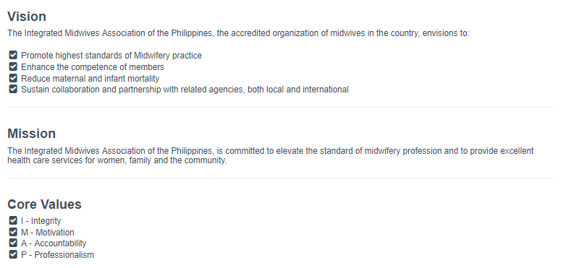

*Box 2: The IMAP’s vision, mission, and core values, as posted on the organization’s website.[10]*

### 4.2 Emerging from the Shell (1975 to 1992)

After the merger of PHIMIDAS and NFFM, IMAP was faced with the challenge to survive and prove itself as an organization. On the other hand, there were with ample opportunities for IMAP to grow as a professional organization, particularly as it was designated as a PRC-accredited professional organization for midwives in the country in 1975.

Since its founding in 1975, IMAP has been led by distinguished presidents with diverse expertise who contributed to its steady growth. The leaders worked hard to establish internal mechanisms that underpin a viable organizational structure inclusive of its broad membership, which spans across the archipelago; and a system of procedures, guidelines, and policies to govern the general operations of the association and guide its members.

The association quickly became an influential advocate for the formulation of midwifery, reproductive health (RH), and family planning (FP) legislations and policies. One of its major achievements during this stage was pushing for the passing of the Republic Act No. 7392 (Philippine Midwifery Act). The law was approved on April 10, 1992 during the term of President Fidel Ramos, who was supportive of the country’s population and RH programs.

### 4.3 The Caterpillar Takes Form (1993 to 2011)

Into its second decade, IMAP’s growth may be likened to the caterpillar phase in a butterfly’s development, with increasing mobility and opportunity for further development. USAID became involved at this stage, with other USAID IPs providing IMAP’s individual members with skills enhancement training and workshops.

##### 4.3.1 Accreditations, Awards, and Memberships in National and International Organizations

As an affirmation of the association’s capabilities and potential, its visibility in the national and international arenas had earned it several recognitions by way of accreditation, awards, and membership in a reputable international organization.

Further strengthening the growing organization at this stage, the Civil Service Commission (CSC) formally accredited IMAP as a full-fledged training institution for midwives on maternal and childcare on July 7, 1997. This created an opportunity for government-employed midwives to enhance their knowledge and skills and to utilize the CSC accreditation for future placements.

Through the efforts of one of its previous presidents, Alice Sanz de la Gente, who went on to become president of the International Confederation of Midwives (ICM) from1996–1999, IMAP became an active member of the Confederation, which is currently based in The Hague, Netherlands. She played a major part in hosting the 1999 ICM Congress in Manila.

In 2009, IMAP became a PRC-accredited Continuing Professional Development (CPD) provider for midwifery. The following year, PRC recognized IMAP with the Outstanding Accredited Organization award.

##### 4.3.2 Bachelor of Science in Midwifery

On October 15–17, 2006, IMAP hosted the 8th ICM Asia-Pacific Regional Conference in Cebu City.[11] It was the first time that IMAP had hosted the regional conference, the theme of which was “Empowered midwives: a gateway to global health.” During the conference, Dr. Catherine Castañeda, director of the CHED Office of Programs and Standards, discussed the proposal of the Technical Committee on Midwifery Education to offer a four-year Bachelor of Science degree program in midwifery.

In 2007, the CHED approved IMAP’s two-year midwifery bridging program, paving the way toward the four-year Bachelor of Science in Midwifery (BSM). Per CHED Memorandum Order No 33, s. of 2007, the BSM program consists of general education and professional courses that prepare registered midwives for higher level midwifery competencies as a health care provider: educator, researcher, supervisor, and health care facility manager/entrepreneur. There are still ongoing debates regarding the advantages and disadvantages of the straight four-year BSM course. For now, CHED requires the completion of the two-year midwifery program, and passing the midwife licensure exam to enter the BSM degree program.

##### 4.3.3 USAID TA to Individual Midwives

IMAP has drawn its strength from its thousands of members, and their professional development contributes to the development of the association. The TA that other USAID IPs provided over the years to individual midwives has helped to reinforce the capacity and sustainability of both the individual midwives and IMAP.

USAID provided TA to IMAP members ranging from skills enhancement in delivering MNCHN and FP services to guidance in managing a social enterprise through the following projects: **Technical Assistance for the Conduct of Integrated Family Planning and Maternal Health Activities by Philippine Non-Government Organizations (TANGO)**and its follow-on,**TANGO2;** and **Private Sector Mobilization for Family Health** **(PRISM)** and the follow-on, **PRISM2.**

Recognizing the crucial role of midwives in the delivery of MNCHN, USAID extended TA to individual midwives to enhance their skills and at the same time improve their economic circumstances. Against the backdrop of a Philippine Population Management Program (PPMP), which advocated responsible parenting to achieve the desired number, timing, and spacing of children and the improvement in MNCHN,[12] **TANGO**  (1993–1995) worked closely with the Institute of Maternal and Child Health (IMCH) and the Integrated Maternal and Child Care Services and Development, Inc. (IMCCSDI). TANGO converted clinics into franchises by transferring their ownership to service providers who had been employees of these two non-governmental organizations (NGOs). IMCH continued to operate with the IMCH name, and its clinic ownership was transferred to physicians, nurses, or midwives as franchisees. Meanwhile, the IMCCSDI adopted the “Family Care” brand name and clinic ownership was transferred to midwives as franchisees. In addition to training the franchisees on business practices, TANGO trained them on FP service delivery and counseling, thereby transforming the clinics into centers that raise awareness about FP and offer FP services and counseling.



Drawing valuable lessons from TANGO, USAID launched TANGO 2, also known as the Philippine NGO Strengthening Project, in 1994 just before the end of TANGO. TANGO 2 worked closely with NGOs in various regions of the country, and with midwives who had no prior affiliation with IMCH and IMCCSDI and would later make up the Well-Family Midwife Clinics (WFMCs). Launched in 1997, the WFMC project developed, implemented, and evaluated the private sector-oriented models of service delivery for FP and basic MCH services. In bolstering such services among these providers, the project addressed findings of earlier studies on health care practices and preferences that the majority of both married and single Filipino women, especially those residing in provinces, prefer the services of midwives for their RH needs. By enhancing the relevance of the clinics this way, TANGO 2 expanded and improved the sustainable practice of private midwives.

*Box 3. The Well-Family Midwife Clinic in Pasig City, one of the WFMCs established through TANGO 2. This WFMC caters to underserved mothers in Pasig and nearby cities.*

While TANGO supported clinics that targeted low-income clients, TANGO 2 focused on service provision for families who can afford to pay a moderate amount for quality FP/MNCHN services. USAID continued to assist the WFMCs in business planning, social franchising, and management. Social franchising took the form of private-public partnerships. Before the project ended in 2003, TANGO, in an effort divest itself of the role of franchiser, assisted the WFMCs to form what they called the WFMC Partnership Foundation, Inc. (WPFI). WPFI was registered with the SEC on June 18, 2002. To date, 29 clinics all over the country carrying the WFMC brand are offering FP/MCH services, and a birthing facility for uncomplicated deliveries.”[13]

Two years later, USAID provided additional TA to individual midwives through **Private Sector Mobilization for Family Health** **(PRISM)** (2004–2009). USAID worked closely with health NGOs, microfinancing institutions, and midwives’ associations (including IMAP) and provided direct TA to individual private practice midwives (PPMs) with birthing homes. In 2005, the DOH issued a circular (in 2005) on the viability of establishing and accrediting birthing homes, where midwives could practice their profession in a private capacity outside of a hospital setting. In 2007, the number of certified midwives in the country had grown to approximately 40,000, with 40 percent in private practice and the rest either in government and privately-owned clinics and hospitals or engaged in other related jobs.

PRISM facilitated an increase in the number of accredited midwives running successful practices by assisting them to qualify as a back-up or referral for physicians and hospitals. The project also worked with the IMAP Bohol Chapter to assist the PPMs to fulfill the requirements for PhilHealth accreditation. (See Box 4)

***Box 4. The Bohol IMAP Lying-in Clinics: A Story of Self-Reliance***

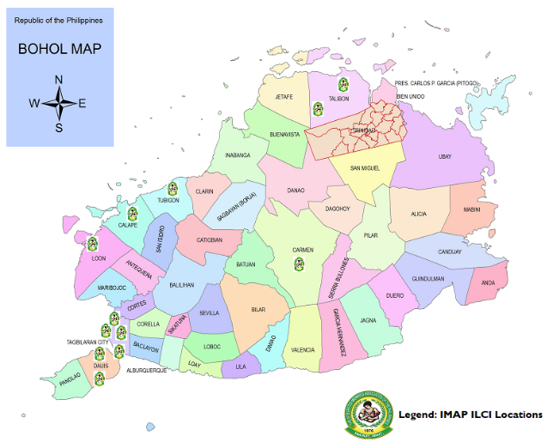The Bohol IMAP LICs are model facilities worth replicating. They carry the “IMAP” brand, which clients associate with quality and affordable FP/MNCHN services.

These clinics have contributed toward:

* Decongesting hospitals through a formal agreement authorizing them to handle non-complicated births;
* Providing an option for cheaper but safe and effective FP services;
* Assisting in the preparation of documentation reports that are submitted to the city/municipality; and
* Reaching underserved communities, including those in geographically isolated and disadvantaged areas (GIDAs).

In addition, the clinics in Bohol show good performance against the following indicators of long-term sustainability:

**Strong PPPs***.* IMAP was able to forge strong linkages with community leaders (e.g., barangay captain) and even with the key persons in the local government units (e.g., PHO, MHO)

**Improved financial sustainability.** IMAP-Bohol has provided TA to member midwives aspiring to qualify for PhilHealth accreditation, leading to the establishment of 14 accredited clinics that now qualify for PhilHealth reimbursements for their services.

**Mentoring and Monitoring of Midwives (3Ms)**. The Bohol IMAP LIC, Inc. formed a core group of trainers who share their knowledge and skills on the different facets of midwifery with their fellow midwives, including various FP methods. These IMAP trainers are tapped for the association’s training needs and by their external counterparts.

In 2012, PRISM2 worked with IMAP to capacitate its member PPMs to partner with the CHO/PHO/MHO in delivering quality and affordable FP/MNCHN services. The project also continued to support the PPMs in obtaining PhilHealth accreditation as service providers and as operators/owners of private birthing homes. In addition, PRISM2 helped PPMs and private birthing homes integrate with the service delivery network (SDN)[14] for FP/MNCHN.

PRISM2 also trained numerous midwives on intrauterine device (IUD) insertion, but few women accepted this method. As a result, after a year, the midwives lost confidence in providing this service due to lack of practical application.

IMAP became involved toward the end of PRISM2 in providing training on Family Planning Competency-Based Training (FPCBT) Levels 1 and 2 in Bohol and Cebu.

### 4.4 The Chrysalis Unravels (2012 to Present)

IMAP continued its journey to “take wing” (self-reliance) with the strengthened competencies of its individual members resulting from a combination of direct TA from USAID and the supportive policies of the government. In 2012, through the initiative of leader midwives and the DOH Secretary, the House of Representatives approved a bill to grant midwives additional scope of practice and provide them with continuing professional education. President Benigno Aquino III, in addressing a midwives’ convention in 2015, recognized the crucial role of midwives in comprehensive health care reforms as the country focuses on the welfare of women and children, two of the more vulnerable sectors of society.

The DOH Administrative Order, “Guidelines in the Administration of Life-Saving Drugs during Maternal Care Emergencies by Nurses and Midwives in Birthing Centers,” further empowered and expanded the role of midwives.

By this point, midwives had started to become recognized as the front-liners for MNCHN and other public health programs. It was during this period when IMAP underwent the USAID NUPAS, which assessed its readiness to receive USAID support. In 2012, USAID granted conditional approval for IMAP to implement the USAID activity on Community Maternal, Neonatal, Child Health, and Nutrition Scale-up (CMSU), while a USAID senior financial analyst assisted IMAP to develop a corrective action plan and measures to strengthen its management and operations, to be executed in the first six months of project life. In addition, IMAP benefited from TA from another USAID-supported activity called Strengthening CSOs. After CMSU ended in 2016, IMAP obtained USAID support for the follow-on activity, CMSU2 (2016-2019).

##### 4.4.1 Community Maternal, Neonatal, Child Health, and Nutrition Scale-up

The USAID CMSU activity came at a time when the country was lagging behind its target in meeting the Millennium Development Goals (MDGs) on reducing child mortality and improving maternal health. Also, during this time, a survey on those who trained in basic emergency obstetric and newborn care (BEmONC) showed a significant gap between training and practice, with only 4 percent of trained midwives practicing what they had learned. This project was implemented to help the DOH in addressing the low proportion of skilled birth attendance and facility-based deliveries, inadequate and delayed antenatal care consultation, limited adoption of essential intra-partum and newborn care (EINC), low practice of the initiation of breastfeeding and exclusive breastfeeding, missed opportunities to integrate FP and MCH services, non-inclusion of youth as targets for FP services, an abundance of poor women with unmet needs for FP and MCH, socioeconomic constraints to facility-based delivery, and limited number of Midwife Certification Program (MCP) and Newborn Care Package-accredited facilities.[15]

As noted by the Iloilo Chapter President, “Midwives offer great potential for addressing human resource, service availability, and quality gaps in MCH and FP programs. Senior or experienced midwives can be tapped to support the development of younger, less experienced ones…as mentors and trainers to unleash the[ir] greater potential.”[16]

Through the project, IMAP was able to provide significant support to the Philippine government’s strategy to achieve the MCH-related MDGs. The project was implemented in several provinces (Pangasinan, Cavite, Batangas, Quezon, Negros Occidental, Iloilo, Davao del Sur, Misamis Oriental, and Zamboanga del Sur) and cities (Quezon, Taguig, Batangas, Naga, Iloilo, and Cagayan de Oro). IMAP, through the three CMSU components of improving midwives’ clinical skills, expanding the reach of midwives, and strengthening the capacity of IMAP (national and local chapters), made significant inroads in its journey toward self-reliance.

4.4.2 Improvement of Midwives’ Clinical Skills

CMSU prepared IMAP to handle the mentoring of trained midwives through the 3Ms program. The 3M program’s peer mentoring approach played a key role in improving the midwives’ clinical skills. Mentoring focused on the seven core skills in midwifery: initial ANC, subsequent ANC, antepartum care, essential intrapartum care, postpartum care, FP, IUD insertion and infant young child feeding. IMAP tapped senior experienced and committed midwives to work with less experienced colleagues to increase local capacity to provide quality MNCHN at the community level. A training module for the 3Ms program was produced, which DOH approved for dissemination to partners. The module comes with 30 credit units from the PRC-Continuing Professional Development (PRC-CPD) Council. The 3Ms program’s integration into the proposed four-year BSM curriculum is awaiting CHED approval.

The following health providers received training on mentoring skills under the 3Ms program:

* 48 DOH-regional and provincial/city FP and MNCHN trainers
* 134 DOH midwife-scholars as mentors in EINC, who reached 670 mentees nationwide
* 366 public and private midwives
* 19 government midwives with funding support from the Iloilo provincial government
* 969 midwives in all 13 sites were mentored in the 3Ms’ seven core skills (see Table 1)

| **Table 1. Total Number of Mentors Mobilized and Number of Mentees Reached (October 2012 – February 2016)** | | | | | | |
| --- | --- | --- | --- | --- | --- | --- |
| **Project Site** | **No. of Mentors Trained on 3Ms** | **No. of Midwives Mobilized** | **% of Trained Midwives Mobilized for Mentoring** | **No. of Identi-fied Men-tees** | **No. of Mentees Observed/**  **Reached** | **% of Mentees**  **Reached by Mentors** |
| Batangas | 29 | 13 | 45 | 159 | 61 | 38 |
| Cavite | 22 | 20 | 91 | 139 | 76 | 55 |
| Davao del Sur | 20 | 18 | 90 | 101 | 62 | 61 |
| Iloilo | 26 | 24 | 92 | 119 | 105 | 88 |
| Leyte | 32 | 17 | 53 | 138 | 67 | 49 |
| Misamis Oriental/CDO | , | 36 | 72 | 264 | 154 | 58 |
| Naga City | 28 | 7 | 25 | 145 | 38 | 26 |
| Negros Occidental | 31 | 23 | 74 | 165 | 99 | 60 |
| Pangasinan | 29 | 5 | 17 | 187 | 12 | 6 |
| Quezon City | 22 | 21 | 95 | 118 | 68 | 58 |
| Quezon Province | 34 | 31 | 91 | 174 | 110 | 63 |
| Taguig City | 22 | 11 | 50 | 90 | 31 | 34 |
| Zamboanga del Sur | 21 | 19 | 90 | 106 | 86 | 81 |
| **TOTAL** | **366** | **245** | **67** | **1,905** | **969** | **51** |

*Source: Community MNCHN Scale-Up Project. Project Terminal Report. October 2012–February 2016.*

*March 30, 2016.*

The mentor midwives continue to visit service provider-mentees to help ensure that they are practicing their clinical skills correctly and improve the quality of their service delivery. As of September 2015, 72 percent (410 out of 568) of midwives were assessed on EINC and found to be correctly practicing the crucial tasks. This figure was higher than the 43 percent average for all USAID sites.[17] In addition, health quality monitoring teams were established in all project sites. The DOH had certified 78 midwife-mentees as competent service providers, and 80 midwife-mentors as qualified mentors.

Indicators of the 3Ms program’s sustainability include buy-in among local government partners (with 4 of 13 having allocated budgets for the program), the DOH’s endorsement of the program’s reference manual, and DOH support of IMAP’s initiative to include the 3M approach in the proposed BSM curriculum.

##### 4.4.3 Expanding the Reach of Midwives

To expand IMAP’s breadth of services and relevance, a strategy was devised to integrate PPMs into the public health system. This allowed IMAP to co-manage community health teams (CHTs), thereby reaching more households than CHTs without PPM as members.[18] It also served to broaden IMAP’s mandate to also include health and FP-related advocacy targeting adolescents and youth.

IMAP, with the PHO and DepEd, developed a module for Adolescent Life Skills and Reproductive Health Education (ALSRHE), which used the DepEd Comprehensive Sexuality Education (CSE) standards as reference. The ALSRHE is used in conducting adolescent RH education and to connect adolescents with private health providers. IMAP trained 14 PPMs in Cavite on Adolescent Job Aids, which help them respond to adolescent patients more effectively and with greater sensitivity.[19] In partnership with these PPMs, IMAP provided FP information to 3,327 youth ages 15 to 24 years in six high schools in Cavite.

IMAP also modified the Usapan strategy by developing the *Usapang Kabataan*, an informal communication tool that facilitates reaching out-of-school youth with information about sexuality, high-risk behaviors, and life skills.

While the ALSRHE and the *Usapang Kabataan* were introduced initially in Cavite, IMAP can easily replicate the initiative in other areas of the country.

##### 4.4.4 Strengthening IMAP’s Capacity

Theseries of strategic planning and leadership and resource mobilization training sessions for IMAP national and chapter leaders further strengthened the organization’s capacity potential for long-term sustainability. IMAP produced manuals on national operations, human resources, finance, and procurement and developed strategic plans for the national office and its local chapters. IMAP also established a program management unit to handle matters related to resource mobilization. To further encourage excellence and scholarly pursuits, IMAP is now publishing the “Midwifery Journal of the Philippines,” which features research conducted by midwives.

These capacity-building activities have enabled IMAP to join various policy-related groups and partner with LGUs, including those involved in health-related concerns. IMAP played a key role in the drafting of the Philippine Midwifery Act of 1992. Also, being a PRC training provider, IMAP has been tapped by the DOH as one of its Regional Training Institutions in Regions V and VI.

##### 4.4.5 Community Maternal, Neonatal, Child Health, and Nutrition Scale-up Follow-on

Building on the gains of the predecessor project, CMSU2 further strengthened the role of midwives in improving client access to FP services and bolstered their capacity to offer a wider variety of FP methods, including post-partum FP and MNCH services. The project also assisted IMAP LICs to establish PPPs, especially at the local level. The PPPs enabled the PPMs who are members of IMAP, and private birthing facilities like the IMAP LICs, to become members of the Iloilo’s SDN, along with its highly urbanized city. Under the PPP, the IMAP LICs enjoy logistics support from and sharing of resources with PHO/CHO. The PHO/CHO assist IMAP in identifying public midwives who then receive IMAP training under the 3Ms program. The PHO/CHO later include these midwives in their Quality Assurance Monitoring Teams, of which IMAP is also a member. The QA teams play an important role in ensuring that public hospitals and other public health facilities can provide quality services to clients comparable to universal standards. The activities of CMSU2 include: a mentoring and monitoring approach through enhancing the midwives’ capacities for balanced counseling, interpersonal communications, and respectful care; expansion of FP services by applying the mentoring approach in IUD and PPIUD training; reinforcing the referral practice for other methods; and bolstering service delivery capacity by strengthening, documenting, and facilitating replication of effective PPPs in FP and MNCH. Another activity is the strengthening of the cooperation between midwives and obstetrician-gynecologists and other health professionals by supporting the BEMoNC training and post-training collaboration activities, assisting in securing or strengthening policy support for the proficiency certification of midwife mentors, and supporting the midwives’ agenda for upgrading the midwifery profession toward better quality service delivery.

##### 4.4.6 Other Development Partners Supporting IMAP

In assisting the DOH and POPCOM to achieve the MDGs, IMAP has received the support and endorsement of the DOH and POPCOM. The **DOH** has been working closely with IMAP accrediting and certifying midwives who are qualified as trainers and mentors. **POPCOM Region VII** (2017) awarded IMAP with a grant to conduct Responsible Parenthood classes in barangays during Family Development Sessions for indigent beneficiaries of the *Pantawid Pamilyang Pilipino Program* (4Ps, or conditional cash transfer program).

To illustrate this multi-agency partnership, one midwife explained that IMAP collaborates with the RHU for FP services and POPCOM for FP Days. The IMAP President, Ms. Corazon Paras, affirmed that the Family Planning Organization of the Philippines and other NGOs, also tap IMAP for FP/RH services.

UNICEF supported the training of IMAP midwives on EINC practices, evidence-based standards that are recommended in hospitals with maternal and newborn care services and birthing facilities.[20] Midwives learned about the importance of skin-to-skin contact between mother and newborn, more effective breastfeeding initiation techniques, and safer maternal care practices. **UNICEF Philippines** supported teachers in IMAP’s midwifery schools to improve quality care for women and children both in the intrapartum and postpartum period.[21]

**Merck Sharp & Dohme (MSD)** supported IMAP in advocating for the integration of progestin subdermal implant (PSI) training into the 3Ms program, as well as in monitoring and tracking the progress of the PSI integration. MSD and IMAP developed and reproduced customized in-clinic PSI materials to help raise awareness about the use of this modern FP method among potential clients and to serve as a reference in training other midwives on PSI insertion. Midwives who were IMAP members also attended MSD’s PSI training of trainers. The trainingcapacitated IMAP members to adopt and share best practices regarding PSI provision. MSD also supported IMAP in advocating and raising awareness about the 3Ms program.

# 5. Analysis: Taking Wing—Is IMAP well on its way toward achieving self-reliance?

IMAP’s evolution and development as a professional organization show how its struggles, milestones, and achievements paved the way for the association to continually pursue the path toward self-reliance.

Per USAID’s definition, self-reliance is a country’s (or an organization’s) ability to plan, finance, and implement solutions to its own development challenges. Figure 1 shows the mutually reinforcing factors that determine self-reliance: capacity and commitment. According to USAID, capacity is manifested in “how far a country (or organization) has come in its ability to manage its own development, across the dimensions of political, social, and economic development, including the ability to work across these sectors,” while commitment is shown by the “the degree to which a country’s laws, policies, actions, and informal governance mechanisms – such as cultures and norms – support progress towards self-reliance.”[22] (See Figure 1)

This section presents components of IMAP that indicate it is well on the path to sustainability.

**FIGURE 1. SCHEMATIC FRAMEWORK SHOWING IMAP’S JOURNEY**

**TO SELF-RELIANCE THROUGH CAPACITY AND COMMITMENT**

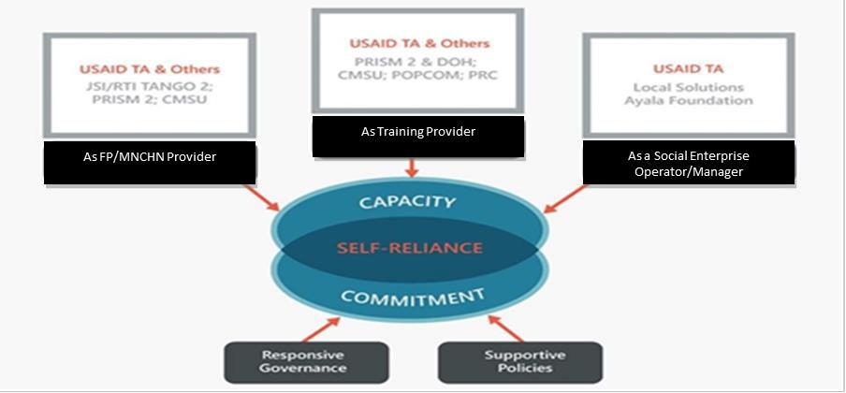

### 5.1 Capacity for Self-Reliance

As IMAP has evolved over the years, it has become more than just a professional association of midwives. It has programs and projects that benefit local communities, governments, national programs, and the international scientific and professional community. It has built a network of local and international development partners.[23]

##### 5.1.1 Legal Personality

IMAP is registered with the SEC and has a well-defined governance structure, from the IMAP National down to its local chapters. Its by-laws clearly stipulate the qualifications, duties, and responsibilities of the members of the Board of Trustees, officers, and permanent committees.

##### 5.1.2 Governance and Organization

IMAP is currently governed by a 15-member Board of Directors who are elected every three years. The members convene to elect a president, a first vice-president, a second vice-president, a secretary, an auditor, a public relations officer, and an assistant secretary. As the chief executive officer of the association, the president oversees all meetings. The first vice-president acts as the president in case of the latter’s absence, with the second vice-president the next in line. The association’s manual of operations describes the functions of other officers. IMAP’s executive director, who is not part of the board, acts as its chief operating officer. Subject to the supervision of the Board of Directors and/or the president, the executive director is responsible for the general supervision of IMAP’s administrative and technical staff. (See Figure 2)

**Figure 2. IMAP’s Organizational Chart**

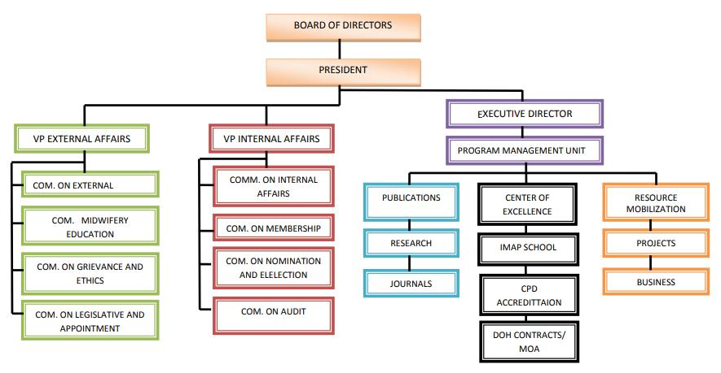

##### 5.1.3 Membership

IMAP has 134 functioning chapters: 126 are in Luzon, Visayas, and Mindanao while 8 are regional chapters. IMAP has had a total cumulative registered membership of 131,000 midwives since 1975. Currently, however, only 30,000 actively participate in IMAP programs and activities.

Interested midwives may apply for membership through any chapter of the association. Association members are classified as follows:

* Active – at least a graduate of the two-year midwifery program who passed the licensure exam and is registered with the PRC; with voting rights
* Affiliate – member of a graduating class; no voting privilege
* Associate – a registered nurse or a registered midwife can be a member but no voting right
* Honorary – not necessarily a graduate or registered midwife, but any individual who has rendered meritorious work in the development of the midwifery profession or assisted in the promotion of the interest and welfare of the association.

Since 2014, IMAP has implemented a PhP500 annual membership fee: PhP150 goes to the member’s local chapter, and PhP350 goes to the national organization to support operational costs. As of this report, IMAP has 12,515 registered members on its website, which would translate to an annual revenue of nearly PhP6.3 million for IMAP National and its chapters if all members were to regularly pay their annual dues. The organization also offers a lifetime membership, which can be obtained by paying the membership fee for five consecutive years and a one-time lifetime membership fee of PhP3,050.

##### 5.1.4 Assets, Revenues, and Financial Capacity

A review of IMAP’s balance sheets indicates strong growth. The value of IMAP’s combined income and donations for 2016 totaled nearly PhP23.6 million, while expenditures amounted to about PhP21.2 million. In 2017, these figures increased significantly, to nearly 37.4 million php and 29.5 million php, respectively. Assets showed a similar growth pattern, being valued at 15.4 million php in 2016 and 23.2 million php in 2017.

In addition to membership fees,IMAP generates revenue from training and convention fees, which amounted to PhP7.6 million in 2017, and oath taking fees (around PhP2,000-3,000 per new member). IMAP also collects fees for the issuance of an IMAP Certificate of Good Standing to private clinics or for the renewal of PhilHealth accreditation. Its training center and dormitory in Pasig City, which became operational in January 2019, also generate revenues.

##### 5.1.5 Accreditations, Awards and Certifications

IMAP’s competencies as an FP/MNCHN service provider and training provider are reflected in its various accreditations, awards, and certifications. IMAP is a PRC-accredited Professional Organization for Midwives and received the PRC 2019 Award for Outstanding Professional Organization. IMAP is also a PRC-CPD Council-accredited CPD Provider for midwifery

IMAP is also a DOH-Recognized Training Center for Family Planning in Region VI and a POPCOM-Accredited Civil Society Organization for Responsible Parenthood and Family Planning in all regions of the Philippines. It is a member of good standing of the International Confederation of Midwives, which is currently based in The Netherlands.

##### 5.1.6 IMAP’s Visibility in the National and International Scenes

IMAP’s visibility in the national and international areas by way of participation in or organizing/co-organizing relevant activities confers credibility and enables it to elicit support to sustain its own programs and advocacy work. Its service to the health needs of the Filipino people can be seen in its regular and active participation in DOH, POPCOM, and LGU-initiated activities and committees. These agencies provide sustained opportunities for IMAP to continually hone its capabilities by being tapped to conduct trainings and provide mentorship to public midwives.

IMAP holds two major activities annually: a conference to support the global celebration of International Day of the Midwife on May 5, and another in October to mark National Midwifery Week.

To celebrate the International Day of the Midwife in May 2018, the Indonesian Midwives Association collaborated with IMAP to hold the International Midwifery Scientific Conference in Jakarta. Later that same year, IMAP held its 44th Annual Convention. In addition, IMAP CEO Patricia Gomez was among the plenary lecturers during the ICM Combined Regional Conference for Eastern Mediterranean, South East Asia, and West Pacific Regions held in the United Arab Emirates in September 2018.

In 2018, IMAP held over 30 local scientific seminars all over the country, 29 regional seminars, 25 CPD training seminars, and two online training sessions.

As part of its local collaborations, IMAP attends the regular meetings of the PRC-CPD Council, the CHED Technical Committee on Midwifery, the DOH RP-RH National Implementation Team, the DOH RPRH Regional and City Implementation Team, and the Perinatal Association of the Philippines Board of Trustees.

##### 5.1.7 Internal Control Systems

With the help of the earlier TA received dealing with business model and solutions, IMAP has developed its own financial management and internal control systems. To date, IMAP’s operations from the National Office down to its local chapters are guided by a set of manuals. Its LICs function autonomously, with each guided by its own set of policies and guidelines. As an organization, IMAP National and its local chapters have formulated a 3 to 5-year Strategic Plan that sets their directions and provides measurable goals that clearly define the key results areas and targets.

### 5.2 Specific Competencies that Built IMAP’s Capacity for Self-Reliance

The TA that IMAP received over the years, mainly through PRISM and PRISM2, hasnot only contributed to its capacity as an organization, but also enabled the Bohol LICs and its individual members to become FP/FMCHN service providers and owner/operators of LICs/birthing facilities. IMAP was specifically capacitated by the TA it received from USAID and other development partners in the following areas: 1) as an FP/MNCHN service provider (through its members who own/operate birthing facilities); 2) as an FP/MNCHN in-service training provider for public- and private-sector midwives; and 3) as social enterprise operators/managers (as in the case of the Bohol LICs and individual members who operate their own birthing facilities/LICs).

IMAP helped in establishing and accrediting LICs/birthing facilities in the Visayas, especially in the provinces of Bohol and Cebu. In Bohol, it has left an indelible mark—clients generally associate IMAP “brand” with FP/MNCHN information and services. Furthermore, the IMAP “brand” has become synonymous with quality, reliable, and affordable FP/MNHCN services in Bohol. The Bohol IMAP LICs are collaborating with local government and have proven PPP to be a viable route for the delivery of FP/MNCHN information, services, and counseling.

5.2.1 As FP/MNCH Provider

USAID trained IMAP midwives to become competent FP providers. These competency trainings involve two levels. Under the Family Planning Competency-Based Training Module Level 1 (FPCBT 1), midwives were trained to provide counseling, short-acting methods of contraception, and *Usapan*; and with FPCBT Level 2 training, they learned how to administer long-acting reversible contraception (LARC) methods such as IUD and PSI.

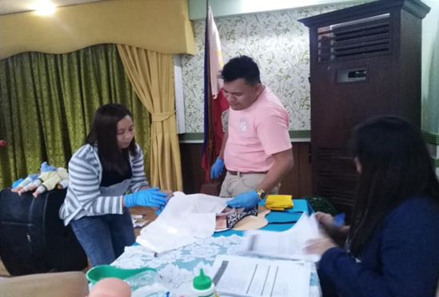

*Box 5. Leyte midwives in Bohol for Basic BeMONC training, a CMSU-funded activity[24].*

*Photo credit: Jacinto Danolco Managbanag, IMAP Facebook page.*

**CMSU** (2012-2015) strengthened the capacity of midwives in the provision of FP/MNCHN, both at the local and national level, through the 3Ms program. The 3Ms approach enhanced their skills in deliveries, antenatal and newborn care, FP counseling and services, and child feeding and breastfeeding.

**CMSU2** (2016-present) further strengthened the role of midwives in improving access to FP services and a wide range of FP methods, including post-partum FP. The project also built the midwives’ capacity in counseling, interpersonal communication, and respectful maternity care. They likewise facilitated the replication of effective PPPs relative to FP and MNCHN. These initiatives have enabled the midwives to be more responsive to client needs that are not typically under their purview. This has broadened the reach of midwives in terms of the number of clients served.

5.2.2 As Training Provider

The TA that IMAP received from USAID IPs such as PRISM and PRISM2 further enriched the association’s capacity as a training provider for other midwives. In IMAP’s 3Ms program, those who received training and had hands-on experience in applying the skills that they gained were tapped to mentor other midwives. (See Figure 3)

**FIGURE 3. 3Ms PROGRAM’s FORCE MULTIPLIER EFFECT[25]**

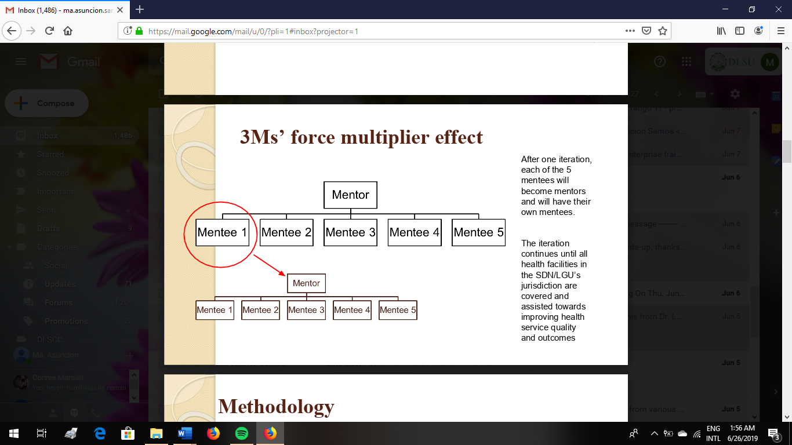

5.2.3 As a Social Enterprise Operator/Manager

To become an effective social enterprise manager, IMAP recognized the need to develop linkages and network with different national and international agencies. It acknowledged that such partnerships would make IMAP’s programs and services more sustainable.

PRISM provided TA to IMAP on social entrepreneurship. Additionally, USAID, through TANGO, provided individual midwives with start-up funds ranging from PhP100,000–300,000 for establishing their own birthing clinics and trained them on basic business skills to manage their birthing facilities. The IMAP members successfully established WFMCs and then created the WPFI, which they also registered with SEC. The WPFI came up with a fully functioning franchise system for the WFMC network. These facilities now serve as centers that offer services and raise awareness about FP. IMAP’s president attested that with the establishment of several birthing facilities, more mothers have become open to options to take care of themselves and their families through proper birth spacing and the use of modern FP methods.

Thus, IMAP was able to establish/accredit several of the Bohol LICs, which have established strong PPPs. USAID supported IMAP to assist midwives to establish their own clinics, train midwives on how to run a social enterprise that offers FP commodities and services, and help midwives obtain accreditation from PhilHealth and the DOH. The DOH provides FP commodities as well as supportive supervision.

One clinic owner mentioned that she received financial assistance and training from CMSU to put up her Well Family Clinic. Another shared the merit of being active in the SDN of the city government because it has reduced fees paid by birthing facilities/LICs to the city.

Despite the delays in the PhilHealth reimbursements for FP-related services, FGD respondents unanimously agreed that running one’s own LIC/birthing facility has been financially attractive. They said that they know of obstetrician-gynecologists and other doctors who wanted to put up their own LICs/birthing facilities.

As a social enterprise, many of the LICs/birthing facilities that received USAID TA are showing signs of success. One FGD respondent, a clinic owner in Pasig City, explained: “My [social] status had changed, financially: first, it has become my family’s ‘bread and butter’; second, I was able to enroll my children in a private school. My clinic capacity is only for one bed, so I can accommodate a very limited number of patients or else PhilHealth will not reimburse me. I also pay for the salaries of four clinic employees.”

IMAP, through its LICs and chapter members who operate private birthing facilities, have provided alternative birthing places that offer safe, quality, and affordable services, thereby decongesting government-run hospitals. In coordination with the DOH, under its Health Finance Development project, IMAP’s LICs and birthing facilities are able to offer benefit packages and approaches that are responsive to the needs of Filipinos. IMAP continues to assist its members in the accreditation of health facilities to extend access to maternity and newborn packages for disadvantaged families enrolled in PhilHealth.

### 5.3 Commitment to Self-Reliance

Commitment requires responsive governance and supportive policies. As applied to IMAP, responsivegovernance pertains to its organizational structure and leadership. Supportive policies, on the other hand, refer to IMAP’s policies, systems, and guidelines that foster its commitment to the organization.

IMAP’s key officers have reinforced the organization’s commitment to elevating the standard of the midwifery profession and providing quality health care for women, families, and communities by putting the mechanisms in place to strengthen staff and members’ skills and capabilities. Having these systems in place will help ensure that IMAP continues to grow and thrive and is able to manage unforeseen challenges.

##### 5.3.1 Responsive Governance

Responsive governance in IMAP is manifested in several aspects.

* ***A Well-Defined Organizational Structure.*** IMAP has a well-defined organizational structure. It has a clear delineation of functions for the Board members, officers, and permanent committees.
* ***Skilled, Experienced Leadership.*** IMAP has been led by competent, accomplished, and dedicated leaders with entrepreneurial skills and the vision to dream big for the organization. It was through the initiative of its late president, Mrs. Alice Sanz de la Gente, that IMAP became an active member of the International Confederation of Midwives. Its current president, Ms. Corazon Paras, has received several local and international awards. She pursues sustainable training programs for practicing midwives, encourages and inspires midwives to start up birthing clinics, especially in rural areas, and collaborates with both private and government organizations in strengthening the midwifery practice. IMAP’s CEO, Ms. Patricia Gomez, is committed to promoting and supporting the professional welfare of IMAP’s membership, and she has earned the respect of numerous key stakeholders including CHED, CSC, DOH, PRC, and others.

“*Our commitment is not just to attend [trainings and seminars] but to implement; not just to increase knowledge, but [make it] life-saving. FP is also a catalyst for change*.”

*– IMAP Officer, KII Respondent*

“*Ms. Azun Paras [IMAP National President] has broad experience. She is one of the pioneers and advocate of IMAP. She travels nationwide. She achieved whatever was needed to advocate this kind of practice of training on FP methods, among others*.”

*– Provincial Health Officer, KII Respondent*

* ***Regular Monitoring of IMAP Chapters***. As an organization of midwives spread across 134 functioning chapters throughout the archipelago and with a total cumulative membership of 131,000 registered midwives since 1975, IMAP endeavors to solidify its commitment to keep the membership intact, informed, and updated by requiring its board members to conduct periodic visits to the different chapters.
* ***Provision for the Regular Gathering of Midwives***. IMAP’s annual conventions and conferences serve as venues for convening midwives from the different parts of the country for updates on the latest developments and issues that may affect their profession, to exchange best practices and insights, and to foster collaboration and camaraderie.
* ***Organizational Sustainability***. Financial sustainability means much more than effectively managing the organization's finances. It includes balancing earnings and expenditures as well as knowing how to invest wisely to build assets over the long term. Major financial decisions are covered by resolutions indicating agreement among IMAP’s officers and board members, which provides for checks and balances.
* ***Program Sustainability.*** Over the years, IMAP has maintained its services through the Bohol LICs and its training programs. IMAP’s leadership has been actively lobbying for the professionalization of midwifery. IMAP implements its internal policies. It advocates for and adopts policies that are supportive of the members’ welfare and that of the organization, such as IRR of RP/RH Act of 2012, PhilHealth policies and package of FP/MNCHN support, and new midwifery policies regarding administration and removal of PSI, among others. It has maintained the tradition of providing quality education and training to equip and empower its members to offer optimal service to clients.
* ***Personnel Sustainability.*** As a professional organization of midwives, IMAP is governed by competent and highly respected midwives in the country. This can also be seen with the autonomous IMAP LICs in different parts of the country that are run by competent midwives, and medical and support personnel. IMAP sends its staff to training seminars related to their work. For example, LIC personnel, especially the midwives, are encouraged to attend training seminars that will enable them to efficiently deliver quality FP/MNCHN service and offer the best patient care.
* ***Reaching Underserved Communities.*** Currently, 14 IMAP LICs are concentrated in the southern part of Bohol province. Ms. Gomez said that IMAP would like to extend is services to Batanes, the northern part of Bohol, Basilan, and other underserved areas in Mindanao. She hopes to achieve this by establishing and maintaining strong partnerships with LGUs, NGOs, and members who own/operate LICs in these areas who share her goal. A provincial health officer (KII respondent) also mentioned that he has been discussing with IMAP President, Ms. Paras, the possibility of extending IMAP exposure in the northern part of Bohol where there are only a few hospitals. He asserted that the essence of public health service is accessibility, sustainability, and ability to provide affordable services. “If we do not have these…those in far flung areas, the GIDAs will be left out,” he said. “…Bohol LICs that are less utilized in certain localities should be tapped so that distant areas can be served, especially the GIDAs.”
* ***Raising the Standards of the Midwifery Profession.*** IMAP has succeeded in making the case to CHED to develop a four-year midwifery degree course. CHED plans to come up with a Road Map on Midwifery that will chart the goals and directions of the profession and further elevate its standards.

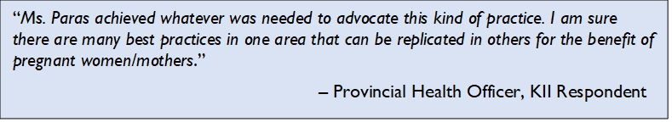

Supportive policies are either internal rules/policies that govern the operations and membershipof IMAP, or external government legislation, administrative orders/policies, and directives that support IMAP’s mission or the midwifery profession.

IMAP’s internal rules and policies have been put in place to safeguard its resources for sustainability and transparency of operations and decisions. It is governed by a set of by-laws, and its operations are guided by its National Operations Manual, Human Resource Manual, Financial Manual, and Procurement Manual. IMAP National and its local chapters also have 3- to 5-year Strategic Plans which provide the association direction, measurable goals, and viable strategies.

Philippine government legislation is supplementing these internal policies with a number of supportive DOH administrative orders and policies, CHED career progression policies, and PRC and CSC policies. Some of these include the following:

* The Philippine Midwifery Act of 1992
* CHED Memorandum Order (CMO) No. 33, Series of 2007 – Policies and Standards for Midwifery Education
* The DOH’s Health Human Resource Development Bureau endorsement of the Midwife Monitoring and Mentoring Reference Manual and the utilization of the peer mentoring approach to implement its Midwifery Certification Program
* The DOH is pursuing a Midwifery Certification Program with the Association of Southeast Asian Nations, whereby member nations subscribe to common midwifery standards
* The Province of Iloilo, through the PHO, will sustain the implementation of 3Ms program as part of the quality assurance for primary care facilities (public and private)

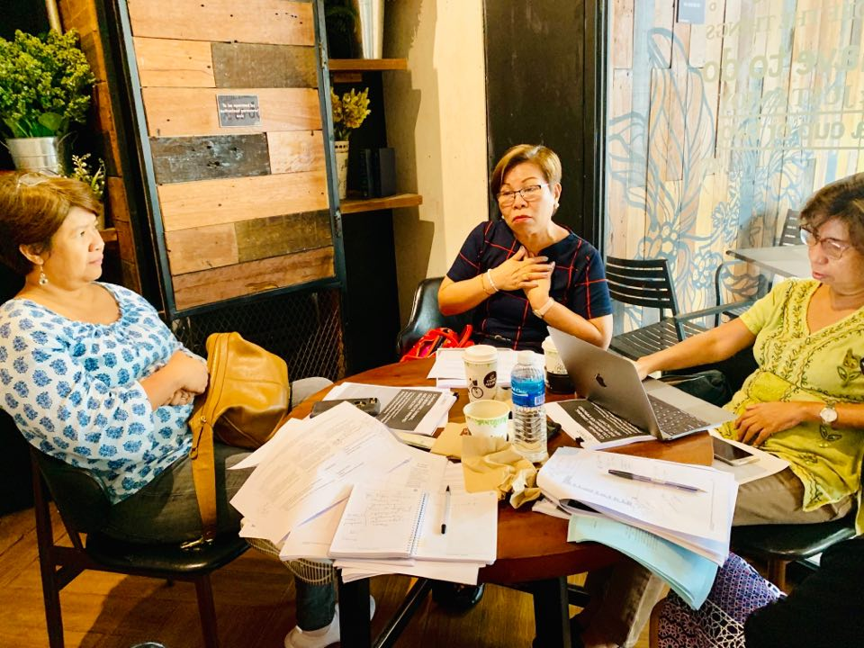

*Box 6. Asked to rate IMAP’s level of self-reliance on a scale of 1 to 10, IMAP CEO Pat Gomez rated IMAP 8 for capacity and 10 for commitment. She noted that before USAID’s senior financial officer came to closely monitor IMAP’s compliance with the components of the NUPAS tool, the association already had the capability and internal control mechanisms in place, but they were not properly documented. Regarding commitment, Ms. Gomez vouched for the current leaders’ unparalleled dedication, love for the profession, and passion to serve the association and members and to fulfill its vision and mission.*

# 6. Development Challenges

IMAP’s steady journey toward self-reliance has not been spared of challenges and difficulties. Most notably, these have included challenges with respect to compliance, need for a training facility, competition with the emergence of other birthing facilities, tensions between public and private practicing midwives, financial sustainability, the need to professionalize midwifery, and reaching remote communities.

***Compliance with Requirements.*** The IMAP Head of Human Resources and Finance said that IMAP had problems adhering to requirements needed to qualify for USAID TA because of fund and time limitations. The same respondent mentioned that private midwives seeking to establish their LICs/birthing facilities sometimes struggled to comply with the required standard clinic/facility size of the DOH. IMAP President Ms. Paras and CEO Ms. Gomez helped address the latter challenge by negotiating with the DOH for the reduction in the space requirement for birthing clinics.

***Need for a Training Facility.*** Developing the capacity of midwives as service providers forFP/MNCHN and as trainers of their colleagues was a challenge because IMAP had only one training site, in Manila, creating an administrative and financial burden of arranging for trainees’ travel and accommodation. Given the positive response of midwives in Bohol, IMAP put up another training center in the province to cater to midwives in the Visayas region. The training center in Totolan, Dauis, Bohol (Box 7) was established and now offers training and skills development and enhancement for midwives in the Visayas Region. In Metro Manila, IMAP’s training center in Pasig has been operational since January 2019. The training center can accommodate 100 participants, and the dormitory can accommodate 32 individuals (who may be training participants or board exam reviewees).

 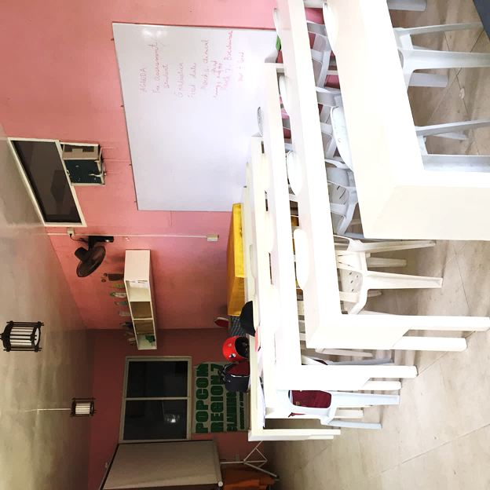

*Box 7. IMAP’s training center in Totolan, Dauis, Bohol*

***Emergence of Other Birthing Facilities.*** IMAP has also needed to contend with competition with theemergence of public birthing facilities For example, the Mother and Child Hospital in Calape, Bohol seemed to have affected the operations of some Bohol IMAP LICs in the sense that the ambulance that the latter was allowed to use previously was now being prioritized for use of the municipal hospital. One Bohol IMAP LIC owner was able to still use the municipal hospital’s ambulance through the help of the municipal mayor, while another LIC owner purchased her own ambulance. In Dauis, a municipal-operated birthing facility will soon be fully operational, raising concerns that this might take business away from the nearby IMAP LICs. However, according to one municipal health officer, pregnant women can always choose from several options for their preferred birthing facility, and there is no coercion or competition between municipal birthing facilities and the IMAP LICs. Ultimately, it is the mother who chooses the facility where she prefers to give birth.

“*There was conflict between LICs and RHU. Some people in the RHU allegedly warned that if the mother gives birth in the LIC, the child will not be given vaccine by the RHU. Otherwise, the partnership between the RHU and the LICs is fine*.”

– *LIC Owner/Clinic Manager, KII Respondent*

***Dual Midwives*.** Dual midwives are those who both practice in public birthing facilities and have a private practice. Some IMAP midwives are also public midwives in the municipality. However, some IMAP midwives in this dual role perceived resentment among public midwives who believed that they were encouraging pregnant women to deliver in IMAP LICs or that they were keeping clients away from the public birthing facilities and monopolizing the services. The IMAP midwives, on the other hand, said that they were harassed by public practice midwives. Due to these issues, some IMAP members decided to give up their public appointment and just focused on their private practice.

***Making Ends Meet.*** Several clinic owners participating in KIIs and FGDs highlighted the challenge of solvency and the constant need to juggle funds to sustain daily operation and upkeep. One contributing factor to this problem that they cited was a decrease in childbirths, likely due to intensified FP advocacy. To compensate for the reduced revenue, they offer services beyond FP and FP/MNCHN such as ear piercing and circumcision. Some clients pay a nominal fee for pre-natal checkups. Another problem cited was delays in PhilHealth reimbursements – often of two to three months – which disrupts the financial management and budgeting of the clinics. Peripheral services offset this somewhat, though some clinics resort to taking out high-interest loans.

***The Need to Professionalize Midwifery.*** Cognizant of the need to keep abreast with international requirements for midwifery,raising the standards of the profession has been adevelopmental challenge that IMAP continues to confront. Ms. Gomez noted inconsistencies in different countries in what is expected of a midwife. For example, registered midwives from the Philippines who go to the Middle East are only accepted for deliveries, while in other countries they end up as caregivers or domestic helpers.

Another major challenge for IMAP is the need to raise the national board passing rate for midwifery, which was 47 percent in November 2018. Relative to this, IMAP has succeeded in pushing for a two-year midwifery program, which is a bridging program toward a BSM degree.

***Reaching the High-Risk and GIDA Communities.*** According to Ms. Gomez, IMAP is collaborating with LGUs in high-risk and GIDA communities for the provision of FP/MNCHN services. Owing to the degree of risk involved in working in these remote areas and considering the safety of midwives, IMAP is looking at all possibilities and treading the situation with utmost care.

# 7. Conclusion

This documentation has found that IMAP has, over the decades, made great strides from its beginnings as a small, loose association of midwives to its current status as an established membership organization with strong leadership and offering an array of member services.

Based on our observations and findings, our conclusions for each of the learning questions are:

***What TA did USAID IPs provide to IMAP that was instrumental in developing its capacity in organizational, business and program management; policy development and advocacy; networking; its ability to secure PhilHealth accreditation; and competencies in providing high quality maternal, newborn, and child health and nutrition (MNCHN) and modern FP information, counseling, and services?***

USAID TA (TANGO, PRISM, PRISM2, CMSU, and CMSU2) has strengthened IMAP capacity in the areas of FP/MNCHN provision and training of other midwives and professionals. Its members who own LICs/birthing facilities acquired the basic skills needed to manage a social enterprise. Some individual members have received seed money that enabled them to purchase equipment and establish their own birthing/lying-in clinics. CMSU 1 and 2 particularly strengthened IMAP as an organization and guided its leaders as they worked toward achieving organizational and financial sustainability.

***From IMAP’s perspective, which among these interventions are most critical in strengthening the association’s capacity and commitment for self-reliance?***

PRISM and PRISM2 seem to have played a pivotal role in IMAP’s capacity building through competency trainings conducted for midwives, skills-building for the start-up of LICs, and assistance in securing PhilHealth accreditation, the last which makes them eligible for reimbursement for a number of services. The accreditation, needed for health service reimbursements, brought in revolving funds to sustain their operations and maintain their facilities.

In terms of strengthening IMAP’s commitment for self-reliance, CMSU facilitated IMAP’s capacity to advocate around the issue of FP/MNCHN with the national and local government and, in the process, realize its potential in lending its professional expertise in these areas. CMSU enabled IMAP to motivate more local chapter members to actively participate in IMAP’s activities, serve as a member of the DOH RPRH National Implementation Team, and regularly attend as development partner in the DOH-RICT in Regions VI, VIII, X and XI. IMAP provided significant TA to the PRC in drafting the IRR of the Philippine Midwifery Act of 1992. Moreover, IMAP was accredited as one of the DOH Regional Training Institutions in Regions V and VI as a PRC training provider.

***Have the NUPAS factors and indices, which were utilized to assess IMAP’s business operations capacity, organizational development, and sustainability prior to receiving a USAID award and TA from Local Solutions and Ayala Foundation USAID Forward, improved today?***

Yes. With the support of a USAID senior finance officer, IMAP was able to comply with the factors and indices of the NUPAS tool. Following a series of strategic planning sessions and a leadership and resource mobilization training sessions, IMAP and its local chapters now have a National Operations Manual, Human Resource Manual, Finance Manual, Procurement Manual, and 3- to 5-year Strategic Plans. IMAP and 11 of its 13 local chapters posted marked improvement in organizational capacity with support of CMSU.

***What additional assistance has IMAP obtained from the DOH, POPCOM, and other development partners to strengthen its capacity in providing FP information and services?***

The DOH and POPCOM provide the leadership and direction for RPRH implementation in the country. In addition to the FP/MNCHN policies, department orders and memorandum orders that emanate from these government agencies, their endorsement and recognition of the capacity building and PPP efforts of IMAP help to sustain IMAP and maintain its credibility as a strong partner for FP/MNCHN services. DOH continues to provide FP/MNCHN supplies and commodities and supportive supervision.

UNICEF’s TA cultivated a better appreciation among the midwives of the value of skin-to-skin contact between mother and newborn. The midwives also learned more effective ways to initiate breastfeeding, safer maternal care practices, and EINC. MSD, on the other hand,supported IMAP in advocating for the integration of PSI delivery into the 3Ms program and then monitoring and tracking progress.

***What are the development challenges confronting IMAP’s efforts towards self-reliance and how is the association addressing these?***

The purchase of the property in Pasig that would house IMAP offices, a training center, and dormitory facilities addressed the need for a training facility in Luzon.

IMAP addressed midwives’ initial difficulty complying with requirements for their newly established birthing facilities through its negotiations with the DOH.

Emergence of other birthing clinics that gave rise to alleged competition was resolved through proper communication between the IMAP LICs and the municipal/district hospital and public birthing clinic administrators.

To address rising tensions and resentment of dual midwives (private midwives who were allowed to practice in public birthing facilities by DOH) by midwives practicing in the public sector, most private midwives gave up their public practice.

To improve revenue streams that decrease due to a decline in clients seeking childbirth services and delayed government reimbursements, IMAP LICs diversified their practices, offering other services such as ear piercing and circumcision.

***What are some examples of IMAP’s GPPIs in the country that illustrate self-reliance in FP/MNCHN?***

Based on how USAID defines a “good practice” and “promising intervention,” IMAP shows potential as a GPPI for expanding FP/MNCHN services. IMAP’s Bohol LICs, in particular, employ good practices such as PPPs and 3Ms.

***What has been the added value of the private-public partnership that IMAP has undertaken in terms of reaching underserved communities?***

IMAP, as a private nonprofit professional organization, trains public midwives to broaden the breadth of their reach to underserved communities. IMAP’s involvement in DOH’s FP/MNCHN advocacy through FP Days, Buntis Day, etc. has made it possible for IMAP to reach these underserved communities.

***How has IMAP contributed to FP/MCH outcomes, especially in underserved communities?***

The IMAP LICs provide affordable birthing facilities and services as well as FP counseling and MNCHN information and assistance. There are 17 PhilHealth-accredited IMAP LICs in Bohol whose goal is to provide safe, accessible, and affordable health care services. Through its inclusion in the SDN, IMAP has been tapped to participate in FP and MNCHN advocacy in underserved areas and GIDAs throughout the country.

# 8. The Way Forward

IMAP has made considerable strides toward becoming a fully independent and sustainable organization and has the capacity and commitment needed for self-reliance. To further strengthen the organization, IMAP should consider taking the following steps:

Governance

* Revisit the vision, specifically by integrating its significant role in the government’s FP program/advocacy to become more responsive to the evolving needs and concerns of the country in this area.
* Create a succession plan at the national and chapter levels, where leaders play a crucial role in the organizational stability of IMAP.
* Install a documentation and information management system at the national level to systematize the storage of data, records, and files and to allow for more efficient retrieval of vital information.
* Formulate a strategic sustainability plan to enable decision-making and the undertaking of activities with a long-term perspective, considering resources and capacities without compromising the needs of incoming members and a new generation of midwives.

Services

* Consider expanding services beyond birthing, e.g., participate in TB or HIV control and prevention programs.
* Strengthen the PPP program throughout the country to reach more underserved communities.
* Institutionalize the standards for developing the competencies of new and young midwives through training and supervision.

Professionalization of Midwifery

* Increase public awareness about the midwifery profession to attract quality applicants and improve performance in national licensure examinations.
* Assess its proposal for a four-year program before the licensure examination and benchmark with Association of Southeast Asian Nations (ASEAN) countries.

Networking and Collaboration

* Provide more platforms for communication, networking, and collaboration with members and potential development partners within and outside the country.
* Continue communication with other medical professionals and those in allied fields to share expertise and exchange good practices.

Research

* Conduct an in-depth study of different IMAP LICs for possible replication in other areas, and to optimize and sustain the scope of PPP to mutually benefit IMAP, government health facilities, and community residents, particularly in the GIDAs and underserved areas of the country.

# References

Candado, Grace. “Quality Assurance Supportive Supervision Visits: A Way Forward Towards Improved Performance and Quality Service for Province-Wide Health System.” Slide Presentation during the Community Maternal, Neonatal, Child Health and Nutrition Scale-up (CMSU) Learning Clinic held at the Richmonde Hotel in Iloilo City. June 4, 2019.

Catubac, Cathy. “Harnessing Private-Public Partnership for Better Health Outcomes: A Private Midwife’s Experience.” Slide Presentation during the Community Maternal, Neonatal, Child Health and Nutrition Scale-up (CMSU) Learning Clinic held at the Richmonde Hotel in Iloilo City. June 4, 2019.

Community MNCHN Scale-Up Project. Project Terminal Report. October 2012 to February 2016. Prepared by the Integrated Midwives Association of the Philippines for the Review of the United States Agency for International Development. March 30, 2016.

De La Gente, Alice Sanz (2008). Midwifery in the Philippines: A laudable service but there are issues and challenges. International Midwifery, Volume 21 No. 4. December.

Dr. Jose Fabella Memorial Hospital Available in <https://fabella.doh.gov.ph/hospital-services/som#history>

Dr. Jose Fabella (inset). Available at <https://en.wikipedia.org/wiki/Jos%C3%A9_Fabella>

Gomez, Patricia M. 2007. The 8th ICM Asia Pacific Regional Congress of Midwives: ‘enriching discussion and exploration’. International Midwifery Volume 20 – Number 2 June 2007, p. 29 Available in <https://www.nurse.or.jp/nursing/international/icm/update/archive/pdf/2007_06_ing.pdf>

IMAP’s About Us Mission/Vision Statement. Available at <http://imapinc.org/public/imapinc/mission.php>

IMAP’s About Us Brief History. Available at <http://imapinc.org/public/imapinc/history.php>

IMAP presenting technical tools to improve the quality of midwifery services during the Community Maternal, Neonatal, Child Health and Nutrition Scale-up (CMSU) Handover Conference in Manila on February 29, 2016. Available at USAID Philippines, <https://www.facebook.com/usaid.philippines/posts/on-february-29-2016-the-integrated-midwives-association-of-the-philippines-prese/1058332400899752/>

Imperial, Feliva. 2019. Empowering Midwives for Better Health Outcomes Through 3Ms. IMAP-Iloilo Chapter. Slide Presentation during the Community Maternal, Neonatal, Child Health and Nutrition Scale-up (CMSU) Learning Clinic held at the Richmonde Hotel in Iloilo City. June 4, 2019.

Innovative Approaches to Maternal and Newborn Health Compendium of Case Studies. August 2013 Maternal, Newborn and Child Health Working Paper UNICEF Health Section, Program Division. Available in <https://www.unicef.org/health/files/Innovative_Approaches_MNH_CaseStudies-2013.pdf>

Philippine Population Management Program. Available at <https://www.doh.gov.ph/book/export/html/1320>

Promoting Family Planning Uptake Through Enhanced *Usapan*. Results from USAID's LuzonHealth Project, October 2018. Available in <https://www.doh.gov.ph/sites/default/files/basic-page/Promoting%20Family%20Planning%20Uptake%20through%20Enhanced%20Usapan.pdf>

Public Private Partnership (2019). https://ppp.gov.ph/ppp-program/what-is-ppp/.

Professional Regulation Commission (n.d.). Midwife licensure examination results Available at <https://www.prc.gov.ph/>.

Philippine Midwifery Schools. Available at <https://www.finduniversity.ph/midwifery-schools/>,

<https://www.pinoymoneytalk.com/top-schools-for-midwife-exam-passing-rate/>,

<https://www.edukasyon.ph/school/>

Trabado, Patricia Grace. 3Ms Experience: How do we engage midwives for better health outcomes.

Slide Presentation during the Community Maternal, Neonatal, Child Health and Nutrition Scale-up (CMSU) Learning Clinic held at the Richmonde Hotel in Iloilo City. June 4, 2019.

USAID. June 2018. Acting on the Call. A Focus on the Journey to Self-Reliance for Preventing Maternal and Child Deaths. <https://www.usaid.gov/sites/default/files/2018ActingontheCall_508.pdf>

USAID (n.d.). Local Capacity Development. Suggested Approaches: An Additional Help Document for ADS 201. Available in <https://www.usaid.gov/sites/default/files/documents/2496/Local_Capacity_Development_Suggest_Approaches_1.pdf>

USAID (n.d.). Private sector mobilization for family health project- phase 2 (PRISM). Project Brief. Available in <https://www.usaid.gov/philippines/health/prism2>

USAID (n.d.). The Self-Reliance Metrics & Country Roadmaps. Available at <https://selfreliance.usaid.gov/>

Well-Family Midwife Clinic Franchise. Available at <https://franchisemanila.com/2014/01/well-family-midwife-clinic-franchise/>

World Health Organization in <https://www.doh.gov.ph/sites/default/files/publications/AdolescentJobAidManualFA.pdf>

1. *Usapan* (conversation) is a group communication technique that aims to directly link FP service delivery with clients.
2. RTI International, USAID, and DOH. Promoting Family Planning Uptake Through Enhanced *Usapan*. Results from USAID's LuzonHealth Project, Washington DC, USA, October 2018. Available at: <https://www.doh.gov.ph/sites/default/files/basic-page/Promoting%20Family%20Planning%20Uptake%20through%20Enhanced%20Usapan.pdf>
3. Catubac, Cathy. Harnessing Private-Public Partnership for Better Health Outcomes: A Private Midwife’s Experience. Presentation. June 4, 2019, Richmonde Hotel, Iloilo City.
4. USAID. Acting on the Call 2018. A Focus on the Journey to Self-Reliance for Preventing Maternal and Child Deaths. USAID, Washington DC, June 2018. Available at: <https://www.usaid.gov/sites/default/files/2018ActingontheCall_508.pdf> Accessed October 9, 2018.
5. IMAP’s About Us Brief History. Available at http://imapinc.org/public/imapinc/history.php.
6. Schools offering Midwifery courses in the Philippines. Available at: <https://www.finduniversity.ph/midwifery-schools/>
7. Best Midwifery schools in the Philippines. Available at: <https://www.pinoymoneytalk.com/top-schools-for-midwife-exam-passing-rate/>
8. Midwifery schools. Available at: <https://www.edukasyon.ph/school/search?utf8=%E2%9C%93&q=Midwifery&program_level%5B%5D=any&button=&utm_source=new_homepage>
9. De La Gente, Alice Sanz. Midwifery in the Philippines: A laudable service but there are issues and challenges. International Midwifery. Volume 21 No. 4. December 2008.
10. IMAP’s About Us Mission/Vision Statement. Available at <http://imapinc.org/public/imapinc/mission.php>
11. Gomez, Patricia. The 8th ICM Asia Pacific Regional Congress of Midwives. Journal of International Midwifery Volume 20, No. 2, June 2007. Available at: <https://www.nurse.or.jp/nursing/international/icm/update/archive/pdf/2007_06_ing.pdf>
12. Philippine Population Management Program. Available at <https://www.doh.gov.ph/book/export/html/1320>
13. Well Family Midwife Clinic Franchise. Available at: <https://franchisemanila.com/2014/01/well-family-midwife-clinic-franchise/>
14. SDN: a network of a network of health facilities and providers offering core packages of health care services within a province or city-wide health system.
15. Community MNCHN Scale-Up Project. Project Terminal Report (October 2012 to February 2016). March 30, 2016.
16. Imperial, Feliva. IMAP: Empowering Midwives for Better Health Outcomes through 3Ms. Presentation. IMAP-Iloilo Chapter. n.d.
17. Community MNCHN Scale-Up Project. Project Terminal Report. October 2012 to February 2016. March 30, 2016.
18. Ibid.
19. Society of Adolescent Medicine in the Phil. Inc., United Nations Population Fund, Department of Health, World Health Organization. Adolescent Job Aid Manual. Manila, Philippines, 2009. Available at: <https://www.doh.gov.ph/sites/default/files/publications/AdolescentJobAidManualFA.pdf>
20. Innovative Approaches to Maternal and Newborn Health Compendium of Case Studies. August 2013 Maternal, Newborn and Child Health Working Paper UNICEF Health Section, Program Division. Available in <https://www.unicef.org/health/files/Innovative_Approaches_MNH_CaseStudies-2013.pdf>
21. Ibid.
22. USAID. The Journey to Self-Reliance. Transformation at USAID. Washington DC, USA. Available at: <https://www.usaid.gov/sites/default/files/documents/1870/J2SR_Fact_Sheet.pdf>
23. Imperial, Feliva. IMAP: Empowering Midwives for Better Health Outcomes through 3Ms. Presentation, IMAP-Iloilo Chapter. n.d.
24. Photo credit Jacinto Dañolco Managbanag. Available at: https://www.facebook.com/photo.php?fbid=2087216071300326&set=pcb.2087217877966812&type=3&theater. Accessed on May 19, 2019.
25. Trabado, Patricia Grace. 3Ms Experience: How do we engage midwives for better health outcomes. n.d.